WIX1002 Fundamentals of Programming
Lab 2: Java Fundamental
1. Write a program that convert the temperature in degree Fahrenheit to degree Celsius.
The program will display the degree Celsius in two decimal places.
Celsius = (Fahrenheit – 32) / 1.8

import java.util.Scanner;

public class FahrenheitToCelsius {
public static void main (String[] args){
Scanner input = new Scanner(System.in);

System.out.print("Enter the temperature in Fahrenheit: ");

double fahrenheit = input.nextDouble();

double celsius = (fahrenheit - 32)/1.8;

System.out.printf("The temperature in Celsius: "+ celsius )

}
}

2. Write a program to calculate the monthly payment for car loan. The following are the
inputs of the program. Output the monthly payment in two decimal places.
P The price of the car
D Down payment
R Interest Rate in %
Y Loan duration in year
M Monthly Payment
M = (P – D) * (1 + R*Y/100) / (Y *12)
import java.util.Scanner;
public class CarLoanCalculator{
public static void main (String[] args){
Scanner input = new Scanner(System.in);

System.out.print("Enter the price of the car (P): ");
double price = input.nextDouble();

System.out.print("Enter the down payment (D): ");
double downPayment = input.nextDouble();

System.out.print("Enter the interest rate in % (R): ");
double interestRate = input.nextDouble();

System.out.print("Enter the loan duration years (Y): ");
int years = input.nextInt();

double monthlyPayment = (price - downPayment)* (1 + interestRate * years/100)/(years*12);

System.out.printf("Monthly payment (M) is : %.2f\n", monthlyPayment); } }
3. Write a program that generates three random numbers. The range of the random
number is 10 to 50. Display the three numbers, sum of the numbers and the average in two decimal places.
import java.util.Random;

public class RandomNumbers{
public static void main (String[] args){

Random rand = new Random();

int num1 = rand.nextInt(41) + 10;
int num2 = rand.nextInt(41) + 10;
int num3 = rand.nextInt(41) + 10;

int sum = num1 + num2 + num3 ;
double average = sum/3.0;

System.out.println("Random numbers: " + num1 + ", " + num2 + ", " + num3);
System.out.println("Sum: "+ sum);
System.out.printf("Average: %.2f",average);

}

}

4. Write a program that converts the seconds to hours, minutes and seconds.
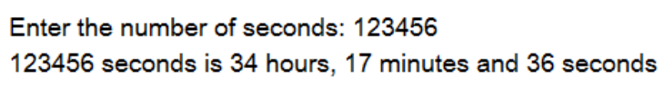
import java.util.Scanner;

public class TimeConvertor{
public static void main(String[] args){
Scanner input = new Scanner(System.in);

System.out.println("Enter the total seconds: ");
int totalSeconds = input.nextInt();

int hours = totalSeconds /3600;
int remainingSeconds =totalSeconds %3600;

int minutes = remainingSeconds/60;
int seconds = remainingSeconds %60;

System.out.printf("%d seconds is %d hours, %d minutes and %d seconds\n", totalSeconds , hours , minutes,seconds);

}
}

5. Write a program that generates one random number. The range of the random number is 0 to 10000. Display the number and the sum of all the digits in the number.
import java.util.Random;

public class DigitSum {
public static void main (String[] args){
Random rad = new Random();

int number = rad.nextInt(10001);
int original = number;
int sum =0;

while(number>0){
sum += number %10 ;
number = number /10;
}

System.out.println("Random number: " + original);
System.out.println("Sum of digits: " + sum);
}
}

6. Write a program that calculates the energy needed to heat water.
Q = M * (final temperature – initial temperature) * 4184
M = Weight of water in kg
Q = Energy in joules
The temperature are in degree Celsius
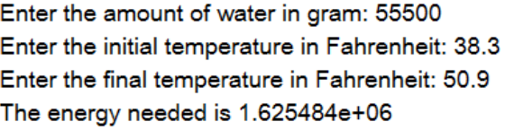
import java.util.Scanner;

public class HeatEnergyCalculator{
public static void main (String[] args){
Scanner input = new Scanner(System.in);

System.out.print("Enter the amount of water in grams: ");
double grams = input.nextDouble();
double masskg = grams / 1000.0;

System.out.print("Enter the initial temperature in Fahrenhait: ");
double initialF = input.nextDouble();
double initialC = (initialF - 32)/1.8;

System.out.print("Enter the final temperature in Fahrenheit: ");
double finalF = input.nextDouble();
double finalC = (finalF -32)/1.8
double energy = masskg * (finalC - initialC) * 4184;
System.out.printf("The energy needed is %.6e\n",energy); } }

